**Kapse and Sons**

**1.-RBC washer tank.**

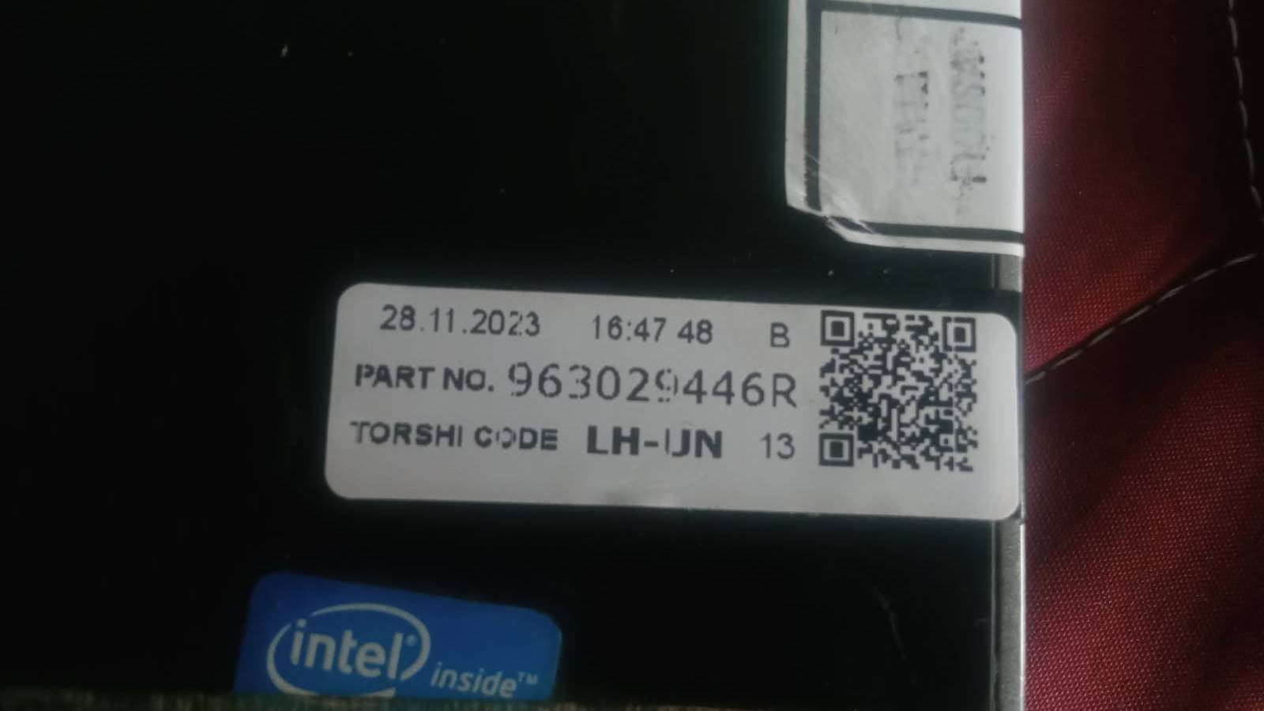

PLC to LABview Byte – Cycle start, Cycle stop, leak test OK, Model selection.

LABview to PLC Byte – software ready.

Station 1:- QR print.

Station 2:- Scanner 1 + Barcode Print(Package print).